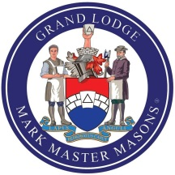 | Grand Lodge of Mark Masons of England and Wales and its Districts and Lodges Overseas  REQUEST FOR A BROTHER CELEBRATION  This form must be completed using typescript or block letters and sent via the Provincial/District Grand Secretary to:  The Grand Secretary, Mark Masons’ Hall, 86 St. James’s Street, London SW1A 1PL

(Initials) (Surname)
- MMH NUMBER (If known)

- BROTHER

- FORENAMES IN FULL

- MASONIC PREFIX

- PROVINCE/DISTRICT

- LODGE NAME ADVANCED

- LODGE NUMBER ADVANCED

- DATE OF ADVANCEMENT

- CONSTITUTION (if not English)

- DATE OF CERTIFICATE PRESENTATION Enter Date

- 50 YEARS 60 YEARS 70 YEARS

(Please tick appropriate box)

NAME OF LODGE SECRETARY

SIGNATURE OF LODGE SECRETARY

NAME OF PROVINCIAL/DISTRICT GRAND SECRETARY

SIGNATURE OF PROVINCIAL/DISTRICT GRAND SECRETARY

DATE Enter Date

